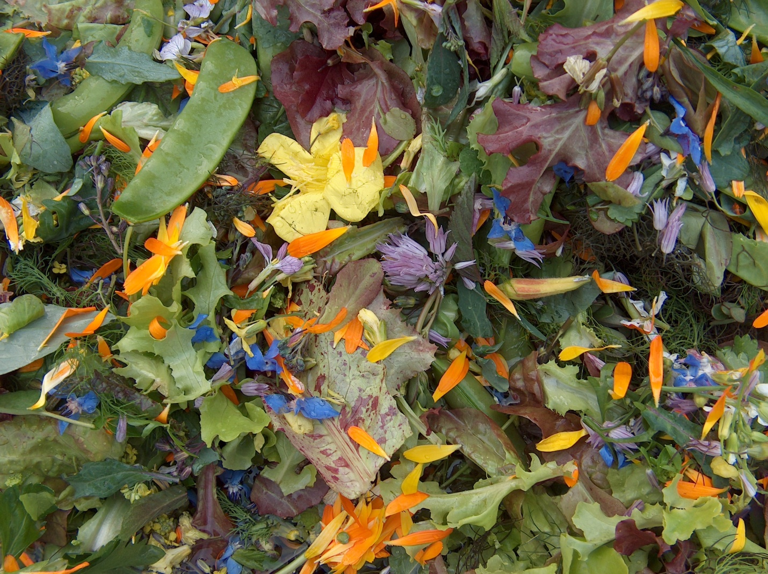
Salad University

The secrets of Floodgate Farm Salad Mix

Elk Session 1: Sunday June 26, 2-5 PM
Elk Session 2: Wednesday August 10, 5:30-8 PM
6141 S. Hwy 1, Elk (by Greenwood Community Center)
At Not So Simple Living Fair, Boonville Fairgrounds, Sat. July 23, afternoon (TBA) – free
Anderson Valley Session 2: Sun. Aug. 14, 2-5 PM
Meet at fairgrounds parking lot to carpool 3 miles SE of downtown Boonville

Bringing vitality to people and the land through healthy food. The right foods provide an energized feeling combined with a stronger constitution with which to fight off disease. Sustainable harvesting means future harvest and a healthy garden ecosystem to limit pests and plant diseases. You will learn common cultivated and wild plants with diverse flavors, textures, and healing properties. Spend 3 hours amongst these plants each season, giving you access to using them and sharing them with others. It will include the art of combining them into salads and green smoothies for a mix of flavors and health-giving properties. These foods are for the adventurous spirit, yet they can be crafted to please many palates.

Logistical details: Classes either by donation ($20 suggested) or work trade (2 hrs per session). All students expected and encouraged to share what they have learned with others. Salad Heals!
Call or email: Bill Taylor at 707-877-1668 or edibleland@earthlink.net

